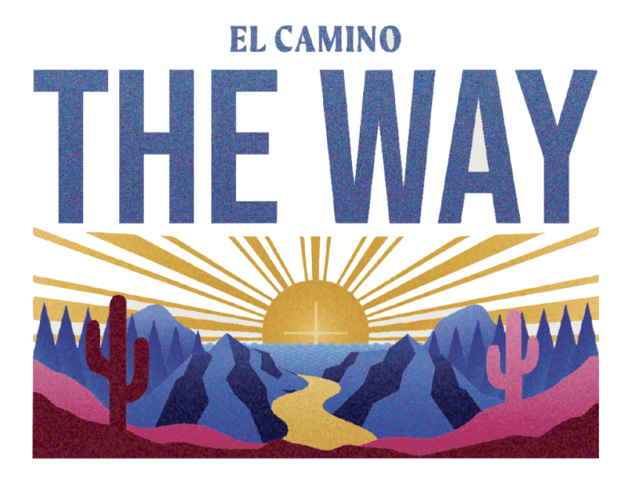
What: The National Catholic Youth Conference where this year around 5,000 youth from around the United States come to a three-day conference and rally to sing, dance, laugh, pray, celebrate, and learn about their faith. See details of potential itinerary on attached page. For more info. check out www.nfcym.org

Who: Any High School youth who will be in 9th grade or above during the 2024/2025 school year. We are also looking for adult chaperones over the age of 21. Young adults who have graduated high school but are under the age of 21 may go as a young adult chaperone assistant, and must be approved by Doris, and completed the Safe Environment training.

Where: Long Beach, CA – Our hotel will be assigned to us, as soon as we register. The conference is in the Long Beach Convention Center.

Why: An opportunity for young people to see the larger youth Catholic Church of the United States of America as well as listen to dynamic speakers, participate in motivating and life challenging workshops, learn more about our faith, and celebrate Mass.

Cost: Fees are subsidized by Youth Ministry Fundraisers. A non-refundable deposit (unless trip is cancelled) of $100 is due by May 15th with the registration form. Youth will need spending money for food and souvenirs while in Long Beach. That is not accounted for in the fees listed later. Teens are expected to participate in the fundraising efforts.

Long Beach NCYC Itinerary - Tentative

Thursday, Nov. 14, 2024

2:00 p.m. Depart for Long Beach

4:00 p.m. Arrive at Hotel & check-in

5:00 p.m. Dinner

7:00 p.m. Gathering and Entertainment

8:00 p.m. Opening Session

10:00 p.m. Return to Hotel

11:00 p.m. Lights out

Friday, Nov. 15, 2024

6:00 a.m. Rise and Shine

7:30 a.m. Gathering and Entertainment

9:00 a.m. Morning Prayer and General Session

11:00 a.m. From now till dinner is fluid. Time will consist of workshops, lunch, and participating in the exhibit hall activities

5:00 p.m. Dinner Break

6:30 p.m. Gathering and Entertainment

8:00 p.m. Night Prayer and General Session

10:00 p.m. Return to Hotel

Saturday Nov. 16, 2024

6:30 a.m. Rise and Shine

8:00 a.m. Gathering and Entertainment

9:00 a.m. Prayer and General Session

11:00 a.m. From now till dinner is fluid. Time will consist of workshops, lunch, and participating in the exhibit hall activities

5:00 p.m. Dinner

7:00 p.m. Gathering and Entertainment

8:00 p.m. Preparation for Closing Liturgy

8:30 p.m. Closing Liturgy

10:00 p.m. Return to Hotel

10:30 p.m. Debrief, food, & prayer

11:30 p.m. Bed

Sunday Nov. 17, 2024

7:00 a.m. Rise and Shine

8:00 a.m. Pack and prepare for departure after breakfast.

10:00 a.m. Arrive Home

Preliminary Cost

Based on four people in a room
Hotel Room | 4 ppl/3nights | $175.00
Conf. fee | Early Bird | $300.00
Transportation** est. |  | $75
T-shirt and dinner last night |  | $50
Total |  | $600.00

From talking to parishes that attended last year, they brought food to make lunches to take to the convention center. We will have a meeting to discuss the options for meals
and transportation. I have inquired about possibly joining another parish if they are taking a bus.

