SERVICE HOUR OPPORTUNITY FOR COMMUNITY HOURS

Saturday, April 27, 2024
Preble Field at
NTC Park in Liberty Station
2455 Cushing Rd, San Diego
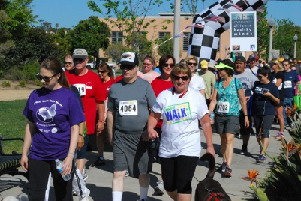
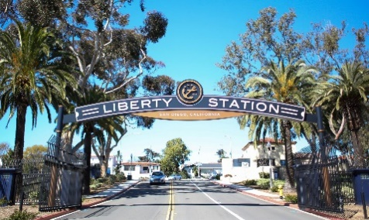

JOIN the OLG New Life Team for a fundraising and awareness walk–
Arrive by 8;00 a.m. for check in, walk starts at 8:15 a.m.
RSVP and permission form required.

Other volunteer opportunities available for set up with the Expo and to work the
Water/Refreshment tables, check in of volunteers, etc. See the volunteer page on the website to sign up online. Set up times and shifts vary from 6:00 a.m. – 9:00 a.m., or 7;30 – noon.

Who is Nami? NAMI San Diego & Imperial Counties (the local affiliate for the National Alliance on Mental Illness) depends on funds and awareness raised through this event to provide education, support, and advocacy for those living with mental illness and their families.

Visit the NAMI.org website and click on the San Diego/Imperial Tab at the bottom to access the sign in page to be a Team Captain or a Walker, or wish to earn a t-shirt.

If you want to join the OLG team click on the QR code below and for further information on this Non Profit organization.

